39.6: a) For a nonrelativistic particle, 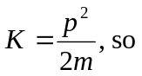
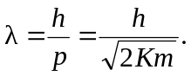
b)

